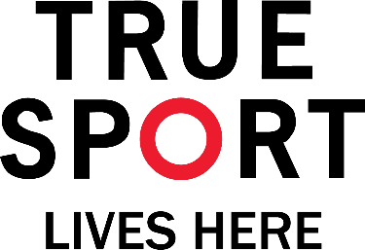

**OFFICIALS’ OATH**

IN THE NAME OF ALL JUDGES AND OFFICIALS TAKING PART IN THE ____________, I PROMISE THAT WE WILL OFFICIATE THESE GAMES WITH COMPLETE IMPARTIALITY; ABIDING BY AND ENFORCING THE RULES WHICH GOVERN THEM, IN THE SPIRIT OF TRUE SPORT.

I pledge our commitment to the True Sport Principles; we will strive to uphold a level playing field and a respectful and positive sporting experience for all.

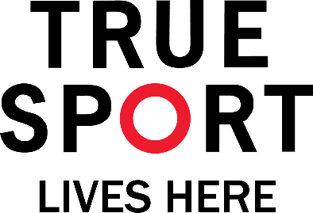

**ATHLETES’ OATH**

IN THE NAME OF ALL COMPETITORS TAKING PART IN THE ____________, I PROMISE THAT WE WILL COMPETE WITH HONOUR AND RESPECT. IN THE SPIRIT OF TRUE SPORT, WE WILL ABIDE BY THE RULES OF THE GAMES AND RECOGNIZE THE COMMITMENT OF THE TIRELESS VOLUNTEERS WHO MAKE THIS EXPERIENCE POSSIBLE.

I pledge our commitment to the True Sport Principles; we will strive for excellence, stay healthy in mind, body and spirit, and have fun.

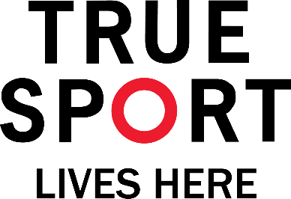

**COACHES’ OATH**

IN THE NAME OF ALL COACHES TAKING PART IN THE ____________, I PROMISE THAT WE WILL COACH IN A MANNER THAT IS CONSISTENT WITH THE SPIRIT OF TRUE SPORT.

I pledge our commitment to the True Sport Principles; we will model what we expect from all athletes; fairness, excellence, inclusion and fun.